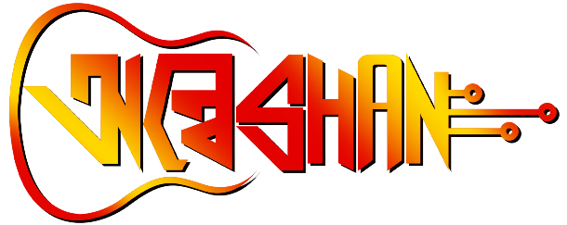

**RECITATION**

Contact: Debdyuti Roy (9007006616),

 Sujoy Modak (8389836099)

**Description:**

Let the words flow! Join us on September 18th at Anweshan 2k23, as our talented students recite their favorite poems. Whether you're a fan of classic verse or modern poetry, there's something for everyone at this event. Remember to have your ID for verification and adhere to the competition guidelines for a fair play. The competition is open to all students, so come ready to show off your skills.

Guidelines

**Rules & Regulations:**

We are thrilled to have you participate in our upcoming recitation screening. To ensure it to be smooth and successful, we kindly request that you familiarize yourselves with the following rules and regulations:

1. Time limit - No recitation will be more than 4 minute

**Political and obscene content should be avoided.

1. The participants must give a print copy of the poem before performing to the judge
2. Participants should not have any copy with them while performing
3. Disrespect/ disobedience to the mentors, committee members, coordinators , volunteers is absolutely not accepted any participant found/reported doing. So, will be dropped from the competition.

All the participants are requested to abide by these rules otherwise it may result in disqualification. For further clarification please contact to the event organizers.

We appreciate your involvement and eagerly anticipate your participation!